Blue Team Shooting Sports Action Pistol January 13th, 2026
COURSE DESIGNER: Ike Starnes

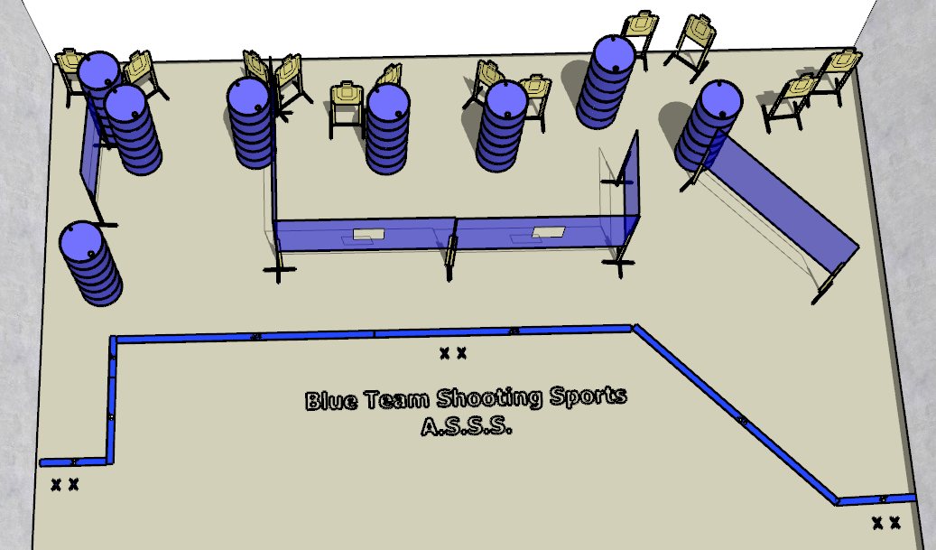

Written Stage Briefings:

Stage 1 – Out with the old, in with the new - is a 24-round, 120 point, Comstock Course. There are 12 cardboard targets. The best 2 hits per cardboard target will be scored.
Handgun start position Feet on left Xs. The handgun is loaded and holstered.
PCC start position Feet on left Xs. PCC is loaded with stock touching belt.
On the audible start signal, engage all targets from within the shooting area.

Stage 2 – May this new year be your best year yet - is a 24-round, 120 point, Comstock Course. There are 12 cardboard targets. The best 2 hits per cardboard target will be scored.
Handgun start position Feet on right Xs. The handgun is loaded and holstered.
PCC start position Feet on right Xs. PCC is loaded with stock touching belt.
On the audible start signal, engage all targets from within the shooting area.

Stage 3 – Every new beginning comes from some other beginning’s end - is a 24-round, 120 point, Comstock Course. There are 12 cardboard targets. The best 2 hits per cardboard target will be scored.
Handgun start position Feet on center Xs. The handgun is loaded and holstered.
PCC start position Feet on center Xs. PCC is loaded with stock touching belt.
On the audible start signal, engage all targets from within the shooting area.

